**Draft Report of a**

**UKCM S-129 workshop**

**Held in Jeju, RoK on 22 and 23 June 2017**

Kensington Hotel

Jeju

**Introduction**

1. Introductory statements were provided by N Lemon (AMSA, S-129 PT Chair) and Prof S Lee (KMOU) introducing the work and aims of the S-129 Project Team and this workshop. A draft agenda (attachment 2) was loosely followed over the course of the workshop.
2. The Korean Registry of Shipping (KR) and the Korean Maritime and Oceans University (KMOU) were acknowledged and thanked for their generous efforts to arrange and host the workshop.
3. Attendees introduced themselves (see list at attachment 1)

**UKCM information sharing**

1. OMC Int’l provided a presentation to describe the scope and nature of UKCM systems that they are familiar with. The presentation was centred on OMC UKCM operations in different ports and waterways and it included a video on the use of UKCM in the port of Port Hedland, Australia (see <https://youtu.be/Fquk0KLb_cU> ). This presentation served as a background briefing on UKCM for those present who had not participated in earlier work of the PT.
2. Participants discussed the nature of UKCM operations and noted that the business case for UKCM was in support of both safety and more efficient port and ship operations.
3. Shindong Digitech provided a presentation on their work on a Korean project dealing with “On board Safe Navigation Support Systems”, where UKC information is to be included as one of several information layers (i.e. Marine Information Objects (MIOs)). During discussion after the presentation it was mentioned that the project could serve to test S-129 on board several vessels based in Korea and which are participating in the Korean project.
4. KMOU prepared a pack of relevant information for the benefit of attendees. This contained two attachments with information for attendees that were not discussed in detail but which are relevant and useful for the project teams’ work. The Korean Hydrographic and Oceanographic Agency (KHOA) and KR with MarineWorks provided the following information:
   1. KR and MarineWorks provided details of their work within the SMART navigation project in Korea, which is a web-based system that shows the features of S-101 ENC and their portrayals and relationships. Examples of actual data are helpful in understanding S-101 (please use this link <http://expirit.co.kr:22222/#!/> ). After the S-129 PS is complete, the UKCM features and portrayals can be uploaded to the previous link.
   2. KHOA provided information to introduce the IHO's S-100 Feature Catalogue Builder (FCB) and the GI registry they are in charge of, and their national Portrayal Catalogue Builder (PCB), and which S-129 will need to be included in. After the S-129 data modelling is completed, KHOA will help to register UKCM features and portrayals on the IHO GI registry.
5. The above presentations are attached as separate pptx files.

**Data model**

1. KMOU provided a presentation summarising work done on the S-129 data model and outlined several other data models being developed that could be useful for this PT. Use of the IEC route exchange standard was recommended. Other relevant data models outlined were:
   1. S-102 (Bathymetric Surface, grids and points).
   2. S-111 (Surface current info, orientation, direction and intensity)
   3. S-411 (Ice information – type, status etc
2. KMOU suggested the PT remain mindful that some components of S-129 could benefit from similar developments in other product specifications (S-XXX).
3. During a general discussion on data modelling the following points were made:
   1. OMC suggested including a third area within the go-area that would serve as a warning to indicate the available UKC is nearing the lower limit, and could be symbolised using an orange colour. The draft data model and portrayal were updated accordingly (see attachments 4 and 5).

* 1. OMC asked if the data model could be deconstructed into separate models to allow for the use of individual elements of the data model without needing to use of the entire model. KMOU agreed to look into whether this can be done (see attachment 4).

* 1. The workshop considered several comments from Eivind Mong, sent by email, related to the data model. These comments were taken into account when the draft data model was updated (see attachment 4).

**S-129 Product Specification testing**

1. The following opportunities for testing S-129 were discussed:
   1. OMC advised they are developing an API for use in testing (Action – OMC).
   2. AMSA will consider and advise whether the Torres Strait UKCM system can be used to help facilitate some testing (Action – AMSA).
   3. Those present agreed that mock-ups can be used for testing the proposed portrayal with seafarers (Action – AMSA, plus others?).
   4. The earlier mentioned testing by Shindong Digitech in Korea is another opportunity to test S-129.
   5. Swedish Maritime Administration (SMA) advised that the Sea Traffic Management (STM) Validation project would be pleased to use their resources and networks to explore the possibility of testing S-129

**Information about the Sea Traffic Management (STM) Validation project**

1. The STM project runs until 31 Dec 2018 and the partnership encompasses simulator centres, ECDIS suppliers, shipping companies and ICT resources. The STM project considers UKC management a potential application within STM with an obvious business case.
2. General information on Sea Traffic Management (STM), including films etc., is available on [www.stmvalidation.eu](http://www.stmvalidation.eu) . The following are useful videos explaining the STM test-beds and services:

http://stmvalidation.eu/videos/sea-traffic-management-services-in-practice/

http://stmvalidation.eu/videos/sea-traffic-management-services-benefits/

http://stmvalidation.eu/videos/stm-validation-300-ships-testing/

http://stmvalidation.eu/videos/emsn-the-european-maritime-simulator-network/

**Mapping of use case to the data model**

1. During the workshop OMC Int’l mapped the use case for pre-planning tidal windows to the data model (version 2, created in March 2017). The results are provided in attachment 6.

**Update on Actions from the second S-129 PT meeting**

1. AMSA provided an update on the status of actions from the second S-129 PT meeting held on 13 and 14 March In Genoa:

**UKCM PT 2 Action item 1. Chair to provide a follow-up proposal to NIPWG and the S-101 Project Team proposing that S-127 include a feature attribute for a UKCM system (in a port or other area). The proposal should outline the information types that should be included.**

*Status – ongoing. Next meeting of the NIPWG is scheduled for March 2018. Chair will submit follow-up proposal as an input to their fifth meeting.*

**UKCM PT 2 Action item 2. Chair to make the Torres Strait UKCM presentation file available on the IHO website.**

*Status – complete. The file is available under the S-129 Genoa meeting documents on the IHO website.*

**UKCM PT 2 Action item 3. Chair to coordinate, by correspondence, a PT discussion and analysis of the benefits of using 8211 or GML to decide which one should be used in S-129.**

*Status – ongoing. OMC suggested to use the method that would need the smallest data packets and is most used at the moment, however OMC would prefer GML be used since it would be easiest from their perspective. The interoperability working group of S-100 should be contacted to seek their guidance/advice (N Lemont to contact the S-100 Interoperability WG).*

**UKCM PT 2 Action item 4. Chair to appoint a member of the PT to be the ‘submitter’ to input S-129 into the IHO registry (note – this person needs to represent an IHO member state).**

*Status - complete. Jeff Wooten (IHO) has established Luke Pugsley as the Submitting Organization for the S-129 PS. These roles are IAW IHO S-99.*

**UKCM PT Action item 5 (replaces UKCM PT 1 Action item 3). The PT agreed work will continue by correspondence starting with updating the draft version of S-129 with the information developed at UKCM PT 2 and included in this report, and in attachments 3 and 4 in particular.**

*Status - ongoing*

**Concluding remarks**

1. AMSA provided some concluding remarks, thanking everyone who attended for their constructive contributions which have helped to further develop S-129.
2. It was stressed that this was a not full and formal meeting of the S-129 Project Team and that the outcomes and steps taken would need to be provided to the full S-129 Project Team for their consideration and advice/agreement.
3. In closing, KR and KMOU were both acknowledged and thanked for their generous support in arranging and hosting the workshop.

**Attachments:**

1. Participants list
2. Workshop agenda
3. Workshop photos
4. Updated draft data model
5. Updated draft portrayal table
6. Use cases with example data included

**Attachment 1**

**Workshop participants**

|  |  |
| --- | --- |
| **Organization** | **Name (day 1, day 2)** |
| KR | Kae-myoung Park (1) |
| Gum-jun Son (1) |
| Min-kee Kang (1) |
| Marineworks co.,Ltd. | Yu-jun Jeong (1) |
| Nam-seon Kang (1) |
| AMSA | Nick Lemon (1, 2) |
| OMC international | Chris Hens (1, 2) |
| Jason Rhee (1, 2) |
| KMOU | Seojeong Lee (1, 2) |
| Hyoseung Kim (1) |
| Hoyong Sim (1) |
| Jieun Jung (1) |
| Changho Mun (1) |
| Swedish Maritime Administration  (STM Validation Project) | Per Setterberg (2) |

**Attachment 2**

**Draft agenda for a**

**S-129 Workshop 22-23 June**

**Venue:**

Kensington Hotel Jeju, Halla Hall

60, Jungmungwangwang-ro 72beon-gil, Seogwipo, Jeju-do, Korea

**Session 1 – Thursday 0900-1030**

1.1 Welcome and introductions  (All)

1.2 Organisational arrangements and workshop expectations (Chair)

1.3 Program outline  (Chair)

1.4 Operational UKCM Presentation (Chris Hens, OMC)

**Session 2 – Thursday 1050-1200**

2.1 UKCM data and feature model development  (All)

2.2 UKCM data model and other S-1XX data models presentation (Hyo Kim, KMOU)

**Session 3 – Thursday 1300-1430**

3.1 UKCM data and feature model development (All)

3.2 Group discussions (All)

- portrayal of time windows

- UKCM features

**Session 4 – Thursday 1450-1700**

4.1 UKCM test planning  (All)

4.2 S-129 related industry project in Korea presentation   (Wesley Jang,

Shindong Digitech)

**Session 5 – Friday 0900-1200**

5.1 Wrap-up of previous day’s outcome 5.2 UKCM workshop report

The work shop will also analyse how the S-129 Product Specification will relate to other S-1XX Products in development and how S-129 might be able to benefit from other S-1xx developments.

Some additional materials will be prepared:

- S-100 feature catalogue builder (FCB) by KHOA

- A web based repository to find the relations between features and portrayals of S-101 by KR

**Attachment 3**

**Photographs**

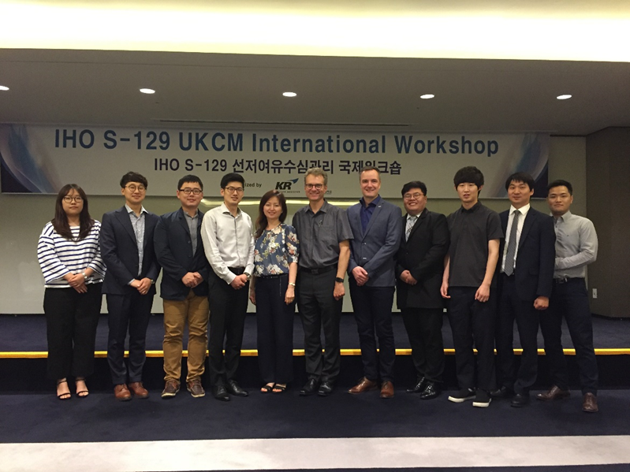

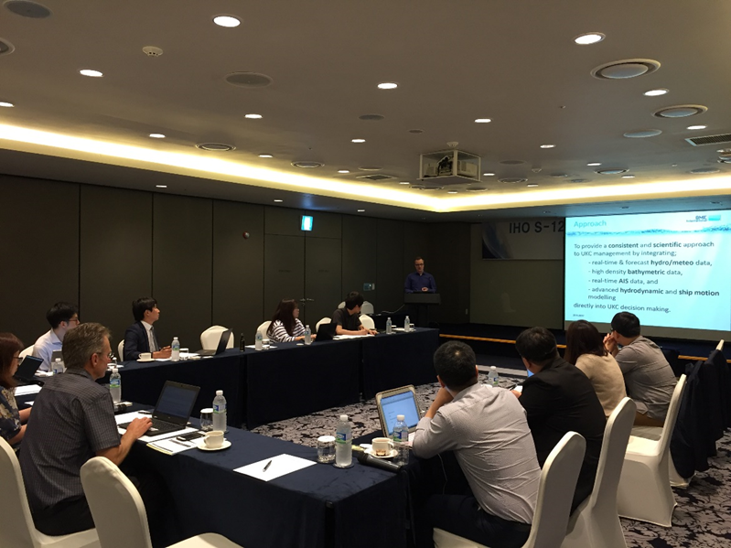

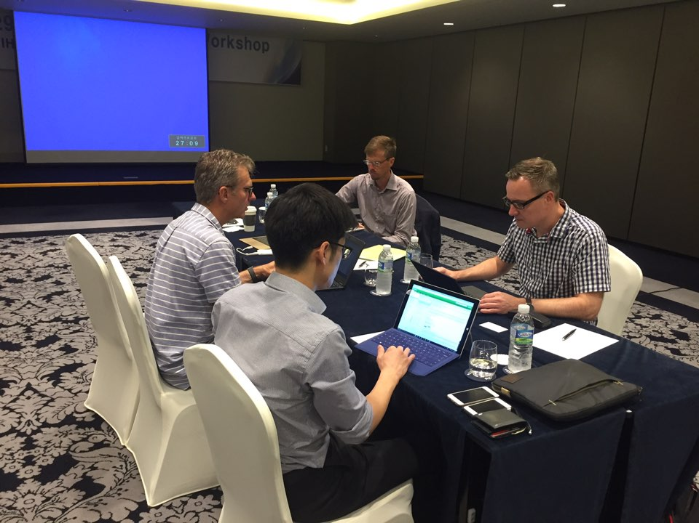

**Attachment 4**

**Updated S-129 Data Model – Jeju, Korea, June 2017**

**Figure 1 Data model**



**Figure 2 Detailed implementation of S129_NavigationArea**



**Figure 3 Detailed implementation of S129_ControlPoint**



**Figure 4 Detailed implementation of S129_Route**



**Attachment 5**

**Portrayal development**

|  |  |  |
| --- | --- | --- |
| Description | Symbology | Notes |
| Control point |  | It is proposed to rotate the symbol such that it is perpendicular to the route. |
| Control point information box |  | ETA refers to the projected time of arrival.  Date/time format is dd/hhmm |
| No-go area  (option 1) |  | The transparent part of the line is inside the no-go area. |
| No-go area  (option 2) |  | Need to consider SCAMIN/MAX. At certain scales the hash pattern may not be clearly visible. |
| Go area |  | To replace the ECDIS safe water area. Normal navigational features to be displayed on top. |
| Route |  | As per existing ECDIS standards.  Information box shows planned speed on each leg. |

**Attachment 6**

Sample S-129 data (22 June 2017)

Sample S-129 has been generated for data model v2.0 (14 March 2017 Genoa) using the AMSA Torres Strait UKCM system for a fictitious vessel.

Use case: Pre-planning– Tidal windows

Based on the following Torres Strait UKCM voyage plan:

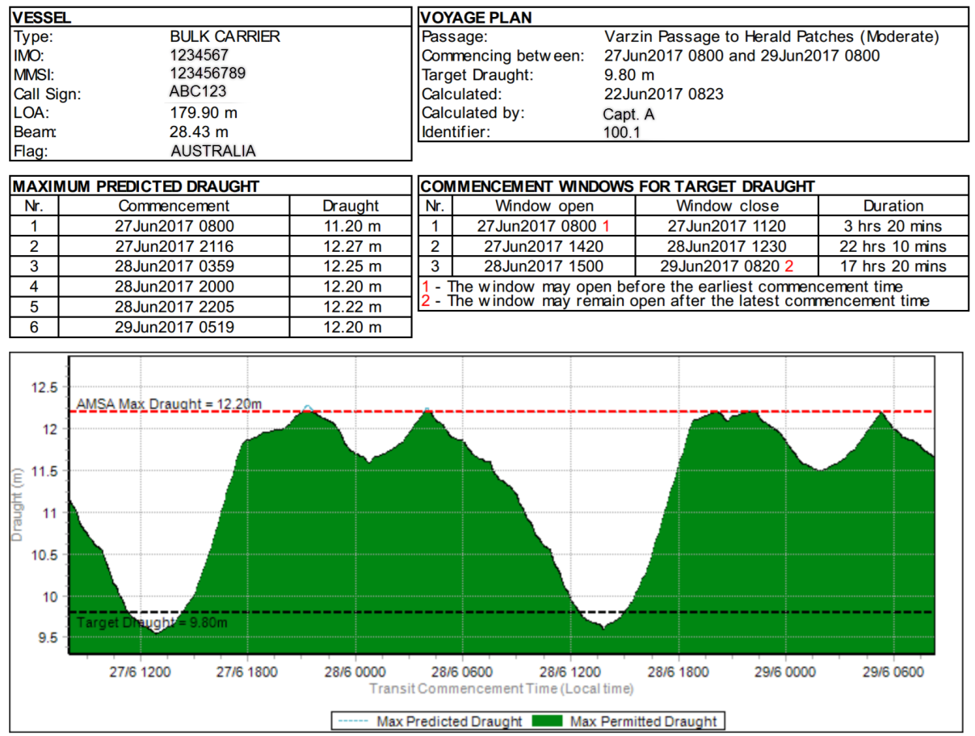

*Figure 1: Sample preplanning advice from AMSA Torres Strait UKCM system*

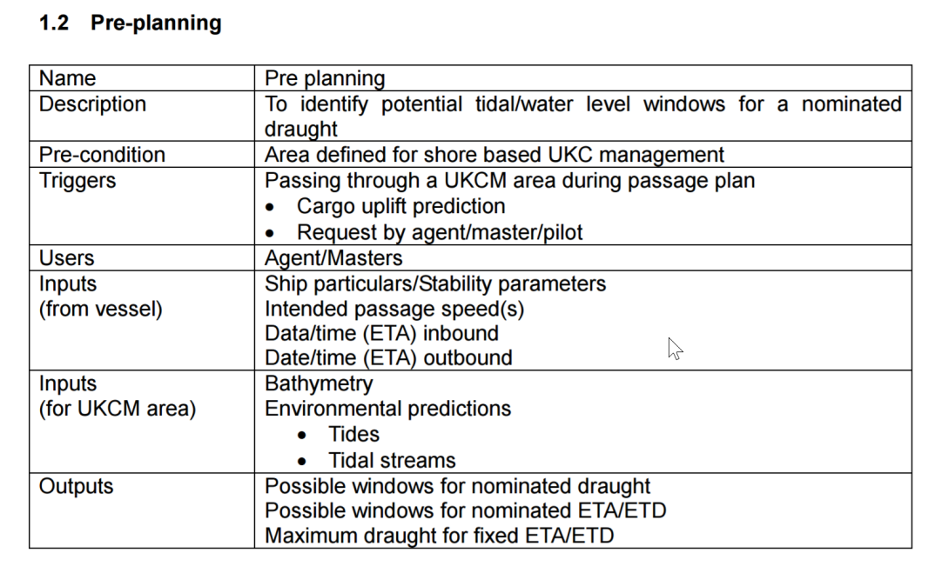

|  |  |  |
| --- | --- | --- |
| **UnderKeelClearancePlan** | | |
| **Attribute** | **Example data** | **Notes** |
| generationTime | 2017-06-21 22:23:00 UTC |  |
| vesselId | 123456789 | Example uses MMSI but should it be IMO number |
| sourceRouteName | Varzin Passage to Herald Patches (moderate) | Route in AMSA Torres Strait UKCM system |
| sourceRouteVersion | 1.0 |  |
| areaBoundary | <?xml version="1.0"?> <gml:Polygon xmlns:gml="http://www.opengis.net/gml/3.2"              xmlns:xsi="http://www.w3.org/2001/XMLSchema-instance"              xsi:schemaLocation="http://www.opengis.net/gml/3.2                                     http://schemas.opengis.net/gml/3.2.1/gml.xsd"              gml:id="ID1" srsName="urn:ogc:def:crs:EPSG::4326" >     <gml:exterior>         <gml:LinearRing>             <gml:posList>141.8204444 -10.45638333 142.4507528 -10.45638333 141.8204444 -10.63043056 142.4507528 -10.63043056</gml:posList>         </gml:LinearRing>     </gml:exterior> </gml:Polygon> | GML coding is used here for simplicity/readability though final encoding might be ISO 8211.  Torres Strait UKCM area bounds as per table below. See also Figure 2.   |  |  |  | | --- | --- | --- | | **Corner** | **Lat** | **Long** | | north west | -10.45638333 | 141.8204444 | | north east | -10.45638333 | 142.4507528 | | south west | -10.63043056 | 141.8204444 | | south east | -10.63043056 | 142.4507528 | |
| maximumDraught | 9.8 | Vessel deepest static draught in metres as used for determining tidal windows.  Model v2.0 lists this as an integer attribute, but it should be a floating point value. |
| scaleMinimum | 1000 | Does this really need to be populated? |
| validStartTime | 2017-06-26 22:00:00 UTC | Presumably a DateTime object can capture timezone information? |
| validEndTime | 2017-06-28 22:00:00 UTC |  |
| ukcPurpose | prePlan |  |
| typeOfCalculation | timeWindow |  |

|  |  |  |
| --- | --- | --- |
| UnderKeelClearanceControlPoint | | |
| Attribute | Example data | Notes |
| point | <?xml version="1.0"?> <gml:Point xmlns:gml="http://www.opengis.net/gml/3.2"              xmlns:xsi="http://www.w3.org/2001/XMLSchema-instance"              xsi:schemaLocation="http://www.opengis.net/gml/3.2                                     http://schemas.opengis.net/gml/3.2.1/gml.xsd"              gml:id="ID1" srsName="urn:ogc:def:crs:EPSG::4326" >  <gml:Point srsDimension="2" srsName="urn:ogc:def:crs:EPSG:6.6:4326">  <gml:pos>141.87 -10.54</gml:pos> </gml:Point> | Current model does not allow for exchange of tidal window information without a geometry attached. For this purpose, the start point of the route has been selected.  Longitude: 141.87  Latitude: -10.54 |
| timeWindow | Window 1:  From: 2017-06-27 08:00:00 (UTC+10)  To: 2017-06-27 11:20:00 (UTC+10)  Window 2:  From: 2017-06-27 14:20:00 (UTC+10)  To: 2017-06-28 12:30:00 (UTC + 10)  Window 3:  From: 2017-06-28 15:00:00 (UTC+10)  To: 2017-06-29 08:20:00 (UTC+10) |  |
| expectedPassingTime | N.A. | Not populated. Does not seem relevant for provision of tidal windows. |
| expectedPassingSpeed | N.A. | Not populated. Not relevant at the preplanning stage. |

**UnderKeelClearanceNonNavigableArea** and **UnderKeelClearanceNavigableArea** features are not relevant and thus not populated.

**UKCM monitoring area as defined in the AMSA Torres Strait UKCM system**

